Introduction
In both the Report Builder and the SOA Editor panels, you can include Images and Thumbnails which are linked to the ASIC MoneySmart website. There are three types of images:

- Image Library
- Thumbnails – MoneySmart Advice
- Thumbnails – Money Smart Videos

Use the Navigation Pane (View) to find the image you are looking for.

Image Library
With the FPA initiative to make the SOA more engaging for the client, we have created a set of images some of which have been used in our Interactive SmartPanels and in our Money Management Videos.

These images are Royalty Free.

When you are using the SOA Editor panels or creating your Report, you can include any of these images. If you can’t find what you are looking, these images were purchased from Deposit Photos. You will find many more images in this style, if you are looking for something different.
https://depositphotos.com/home.html

These images can be copied and pasted into your Report Builder and SOA editor.

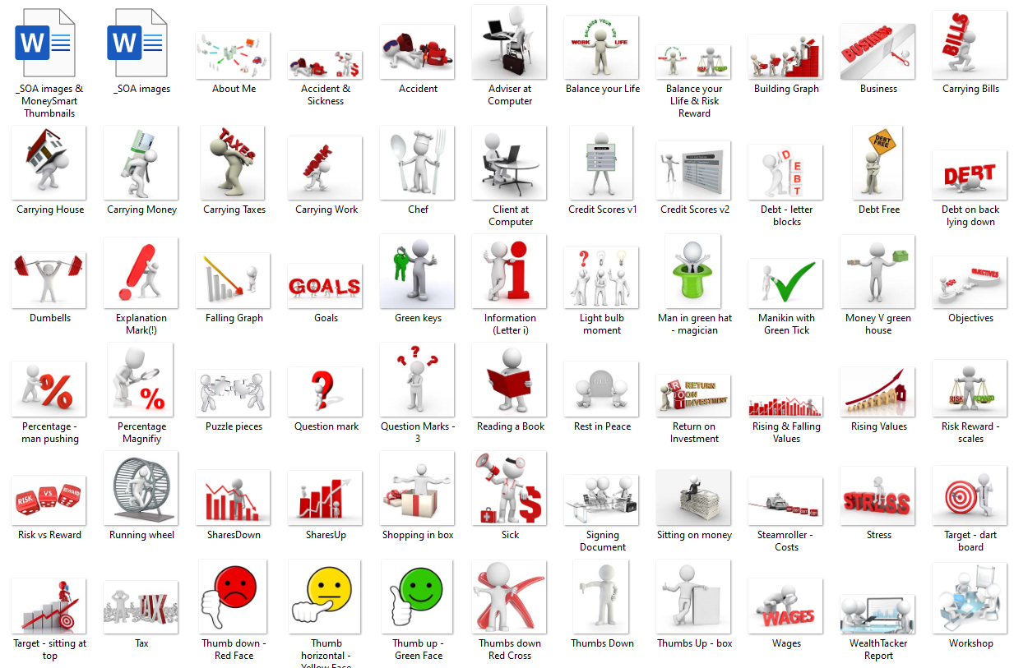

Full List
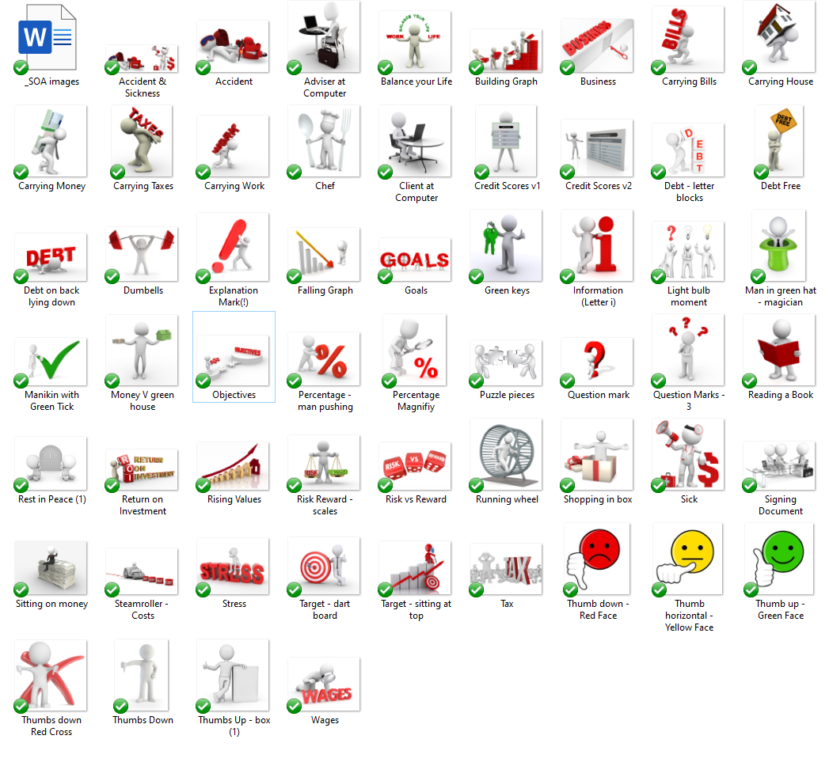

Accident and Sickness


Accident


Adviser at Computer


Balance your Life


Balance your Life & Risk Reward – Scales



Building Graph


Business


Carrying Bills


Carrying House


Carrying Money


Carrying Taxes


Carrying Work


Chef


Client at Computer


Credit Score v1
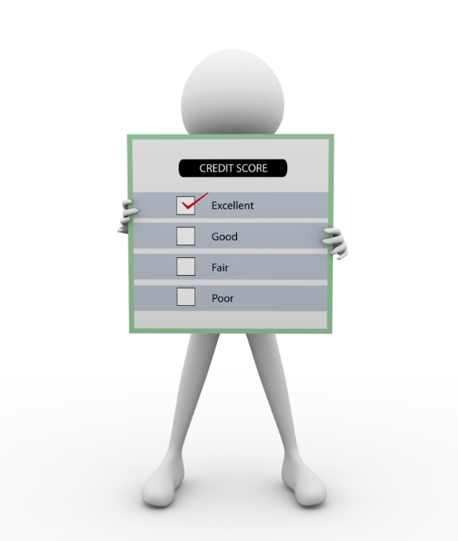

Credit Score v2
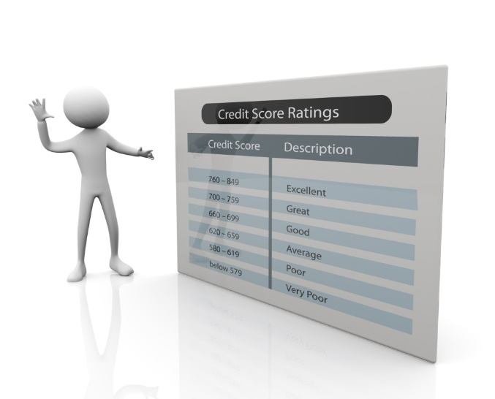

Debt – letter blocks
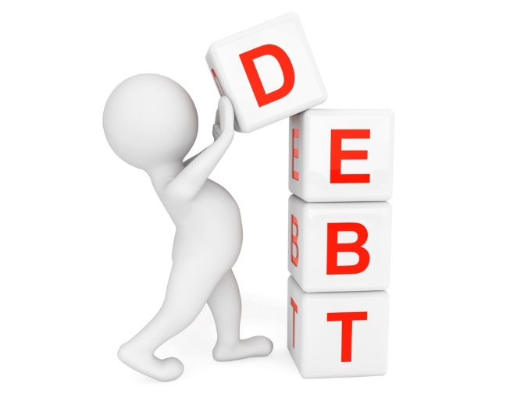

Debt Free
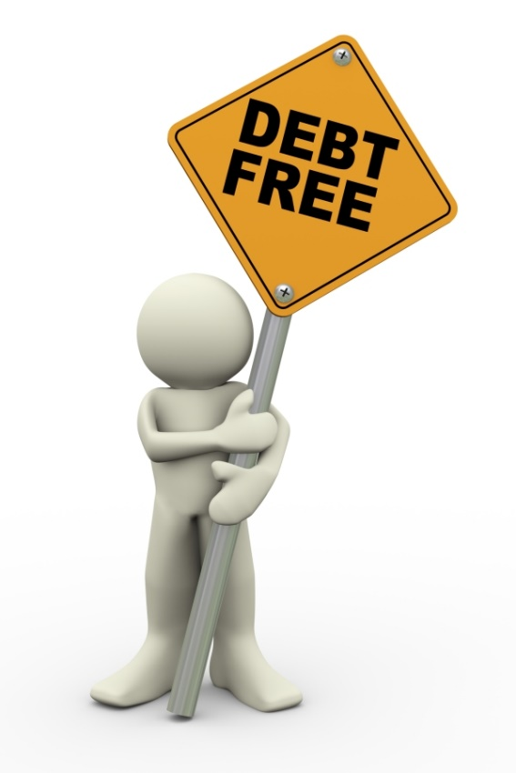

Debt on back lying down
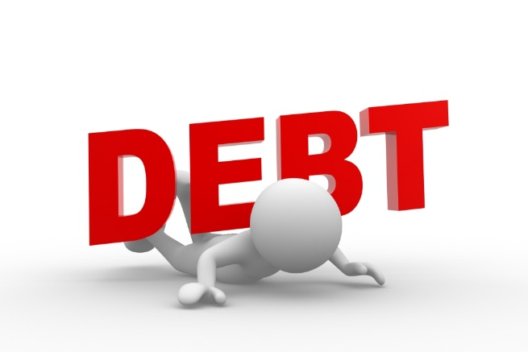

Dumbbells


Explanation Mark (!)


Falling Graph


Goals


Green Keys


Information (Letter i)


Light bulb moment


Man in green hat - magician


Manikin with Green Tick


Money V green house


Percentage – man pushing


Percentage - magnify


Puzzle Pieces


Objectives


Question Mark


Question marks - 3


Reading a Book


Rest in Peace


Return on Investment


Rising Values


Risk Reward - scales


Risk Vs Reward
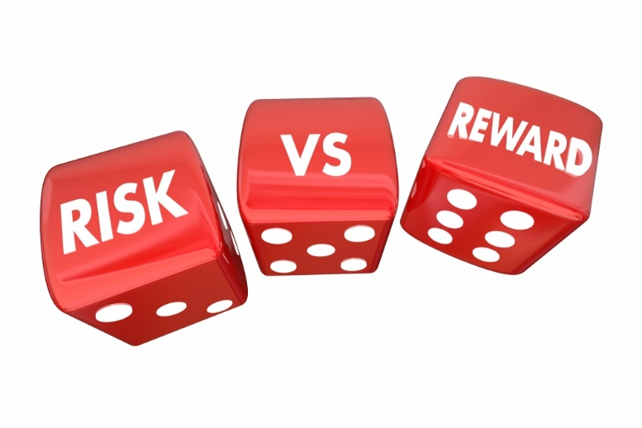

Running wheel
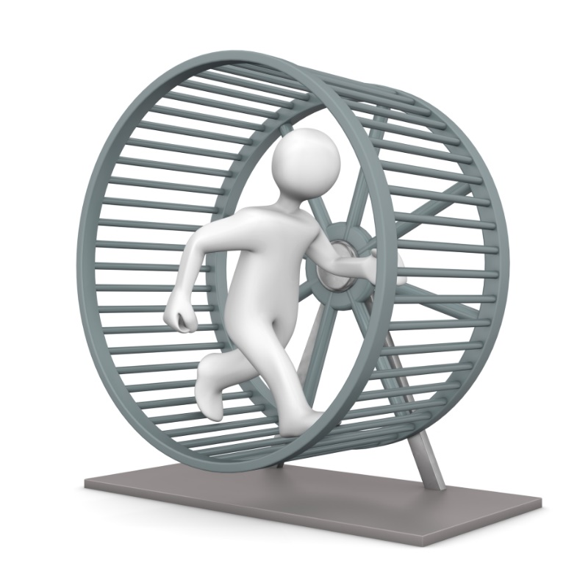

Shopping in box


Sick


Signing Document


Sitting on Money


Steamroller -Costs
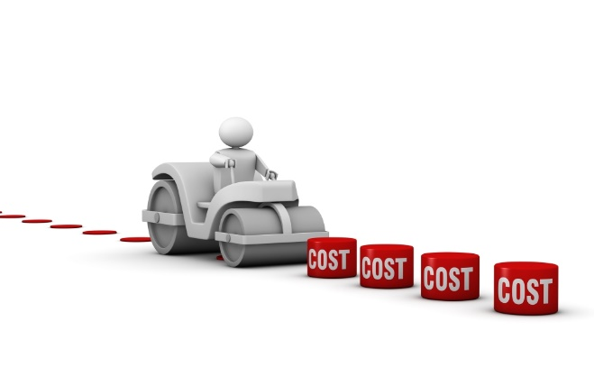

Stress


Target – dart board


Target – sitting on top


Tax


Thumb down – Red Face


Thumb horizonatal – Yellow Face


Thumb Up – Green Face


Thumbs Down – Red Cross


Thumbs Down


Thumbs Up - box


Wages


Wealth Tracker Report


Workshop


MoneySmart Advice
On the Client Review the presentation is:

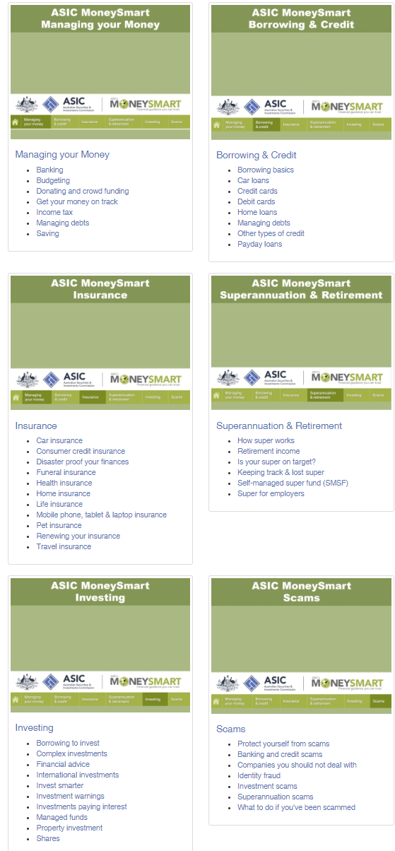
There may be times, when you want to nominate just one of the sub-categories for you client to read. In this case, you may want to add a thumbnail and the link. Therefor all the thumbnails have been included in this document in addition to the links.

The links are:

- Managing your Money (ALL) https://www.moneysmart.gov.au/managing-your-money
- Banking https://www.moneysmart.gov.au/managing-your-money/banking
- Budgeting https://www.moneysmart.gov.au/managing-your-money/budgeting
- Donating and Crowd Funding https://www.moneysmart.gov.au/managing-your-money/donating
- Get your Money on Tract https://www.moneysmart.gov.au/managing-your-money/get-your-money-on-track
- Income Tax https://www.moneysmart.gov.au/managing-your-money/income-tax
- Managing Debts https://www.moneysmart.gov.au/managing-your-money/managing-debts
- Saving https://www.moneysmart.gov.au/managing-your-money/saving

- Borrowing and Credit (ALL) https://www.moneysmart.gov.au/borrowing-and-credit
- Borrowing basics https://www.moneysmart.gov.au/borrowing-and-credit/borrowing-basics
- Car loans https://www.moneysmart.gov.au/borrowing-and-credit/car-loans
- Credit cards https://www.moneysmart.gov.au/borrowing-and-credit/credit-cards
- Debit cards https://www.moneysmart.gov.au/borrowing-and-credit/credit-cards
- Home loans https://www.moneysmart.gov.au/borrowing-and-credit/home-loans
- Managing debts https://www.moneysmart.gov.au/managing-your-money/managing-debts
- Other types of credit https://www.moneysmart.gov.au/borrowing-and-credit/other-types-of-credit
- Payday loans https://www.moneysmart.gov.au/borrowing-and-credit/payday-loans

- Insurance (ALL) https://www.moneysmart.gov.au/insurance
- Car Insurance https://www.moneysmart.gov.au/insurance/car-insurance
- Consumer credit insurance https://www.moneysmart.gov.au/insurance/consumer-credit-insurance
- Disaster proof your finances https://www.moneysmart.gov.au/insurance/disaster-proof-your-finances
- Funeral Insurance https://www.moneysmart.gov.au/insurance/funeral-insurance
- Health Insurance https://www.moneysmart.gov.au/insurance/health-insurance
- Home Insurance https://www.moneysmart.gov.au/insurance/home-insurance
- Life Insurance https://www.moneysmart.gov.au/insurance/life-insurance
- Mobile phone, tablet & laptop insurance https://www.moneysmart.gov.au/insurance/mobile-phone-tablet-laptop-insurance
- Pet Insurance https://www.moneysmart.gov.au/insurance/pet-insurance
- Renewing your Insurance https://www.moneysmart.gov.au/insurance/renewing-your-insurance
- Travel Insurance https://www.moneysmart.gov.au/insurance/travel-insurance

- Superannuation and Retirement (ALL) https://www.moneysmart.gov.au/superannuation-and-retirement
- How Superannuation works https://www.moneysmart.gov.au/superannuation-and-retirement/how-super-works
- Retirement income https://www.moneysmart.gov.au/superannuation-and-retirement/income-sources-in-retirement
- Is your super on target? https://www.moneysmart.gov.au/superannuation-and-retirement/is-your-super-on-target
- Keeping track & lost super https://www.moneysmart.gov.au/superannuation-and-retirement/keeping-track-and-lost-super
- Self-managed super fund (SMSF) https://www.moneysmart.gov.au/superannuation-and-retirement/self-managed-super-fund-smsf
- Super for employers https://www.moneysmart.gov.au/superannuation-and-retirement/super-for-employers

- Investing (ALL) https://www.moneysmart.gov.au/investing
- Borrowing to invest https://www.moneysmart.gov.au/investing/borrowing-to-invest
- Complex investments https://www.moneysmart.gov.au/investing/complex-investments
- Financial Advice https://www.moneysmart.gov.au/investing/financial-advice
- International investments https://www.moneysmart.gov.au/investing/international-investments
- Invest smarter https://www.moneysmart.gov.au/investing/invest-smarter
- Investment warnings https://www.moneysmart.gov.au/investing/investment-warnings
- Investments paying interest https://www.moneysmart.gov.au/investing/investments-paying-interest
- Property investments https://www.moneysmart.gov.au/investing/property
- Shares https://www.moneysmart.gov.au/investing/shares

- Scams (ALL) https://www.moneysmart.gov.au/scams
- Protect yourself from scams https://www.moneysmart.gov.au/scams/avoiding-scams
- Banking and credit scams https://www.moneysmart.gov.au/scams/banking-and-credit-card-scams
- Companies you should not deal with https://www.moneysmart.gov.au/scams/companies-you-should-not-deal-with
- Identity fraud https://www.moneysmart.gov.au/scams/identity-fraud
- Investment Scams https://www.moneysmart.gov.au/scams/investment-scams
- Superannuation scams https://www.moneysmart.gov.au/scams/superannuation-scams
- What to do if you’ve been scammed https://www.moneysmart.gov.au/scams/recovering-your-losses

The thumbnails are:

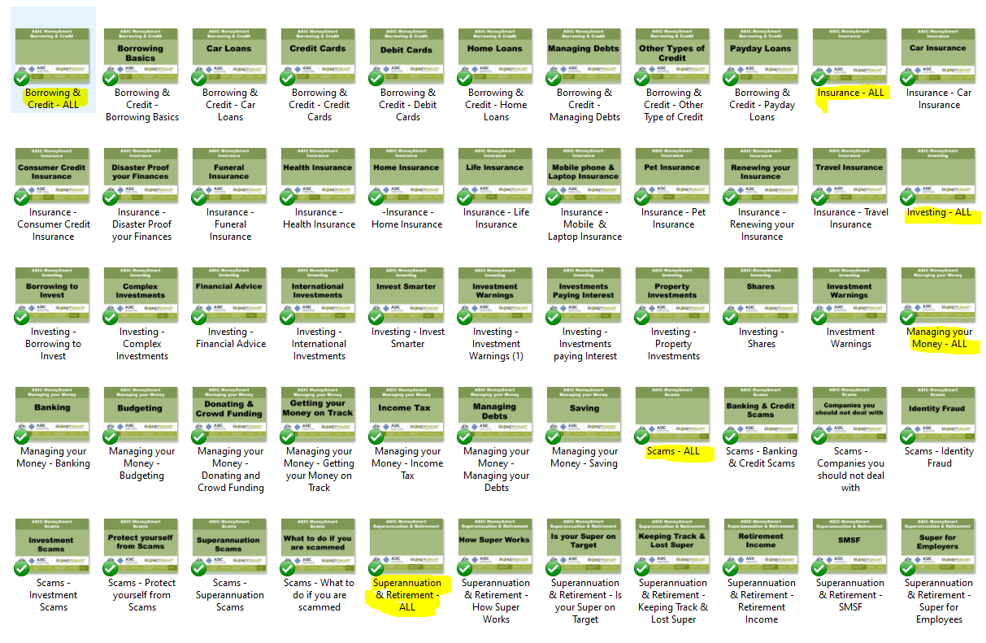

Borrowing & Credit – ALL
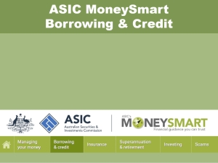

Borrowing & Credit – Borrowing Basics
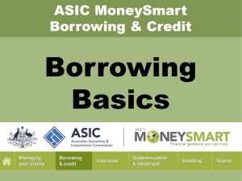

Borrowing & Credit – Car Loans
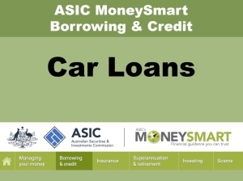

Borrowing & Credit – Credit Cards
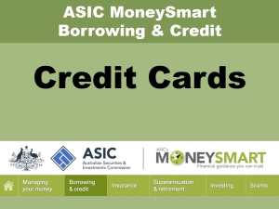

Borrowing & Credit – Debit Cards
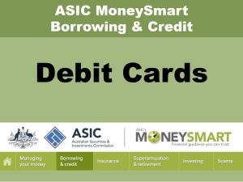

Borrowing & Credit – Home Loans
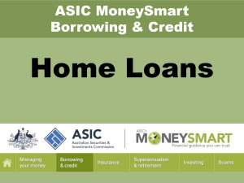

Borrowing & Credit – Managing Debts
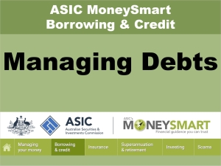

Borrowing & Credit – Other Type of Credit
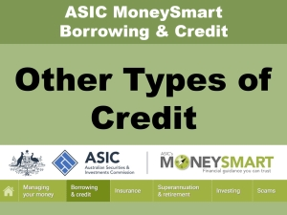

Borrowing & Credit –Payday Loans
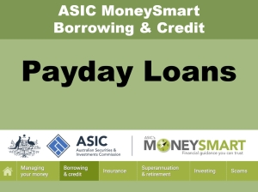

Insurance – ALL
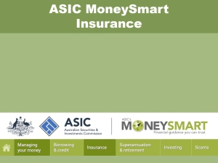

Insurance – Insurance - Car Insurance
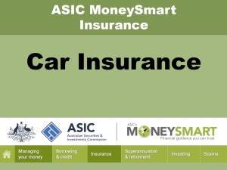

Insurance – Consumer Credit Insurance
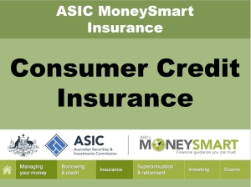

Insurance – Disaster Proof your Finances
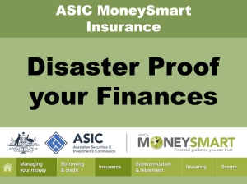

Insurance – Funeral Insurance
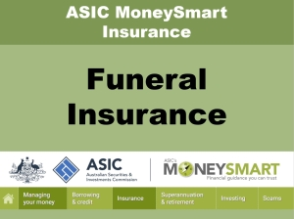

Insurance – Health Insurance
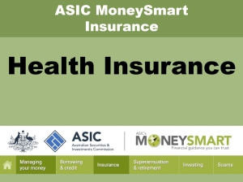

Insurance – Home Insurance
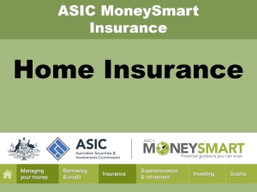

Insurance – Life Insurance
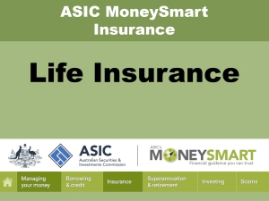

Insurance – Mobile & Laptop Insurance
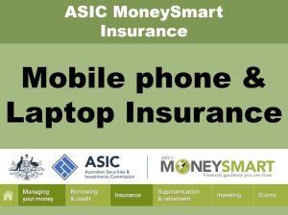

Insurance – Pet Insurance
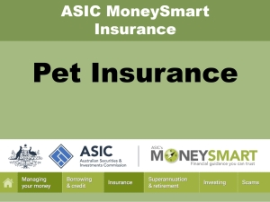

Insurance – Renewing your Insurance
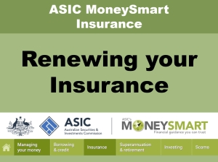

Investing – ALL
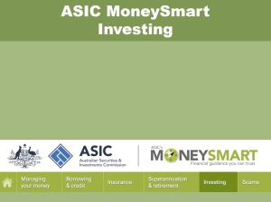

Investing – Borrowing to Invest
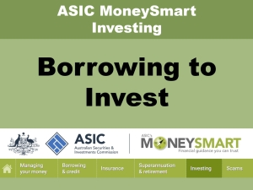

Investing – Complex Investments
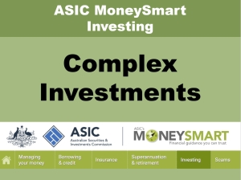

Investing – Financial Advice
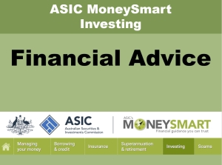

Investing – International Investments
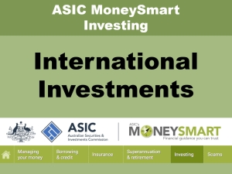

Investing – Invest Smarter
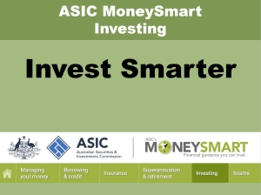

Investing – Investment Warnings
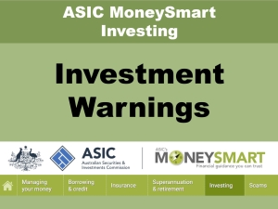

Investing – Investments paying Interest
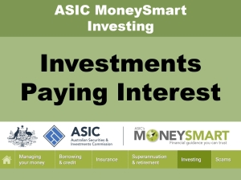

Investing – Property Investments
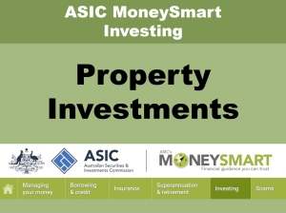

Investing – Shares
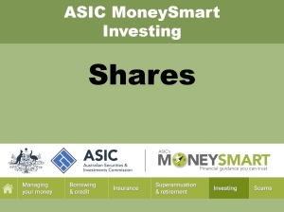

Managing your Money – ALL
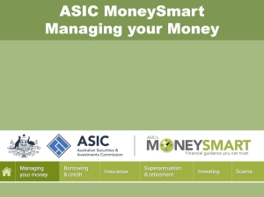

Managing your Money – Banking
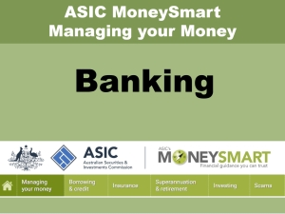

Managing your Money – Money Budgeting
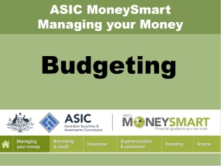

Managing your Money – Donating & Crowd Funding


Managing your Money – Getting your Money Back
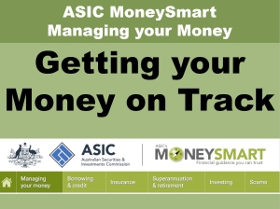

Managing your Money – Income Tax
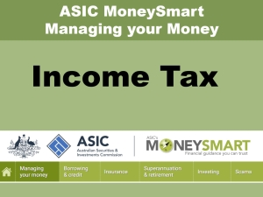

Managing your Money – Managing your Debts
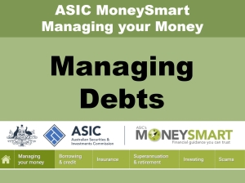

Managing your Money – Saving
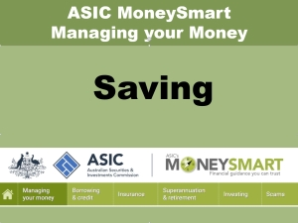

Scams – ALL
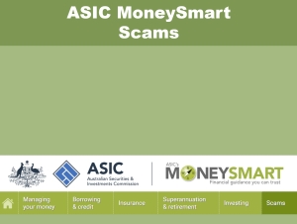

Scams – Banking & Credit Scams
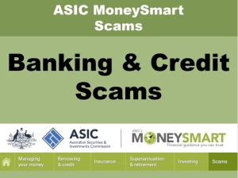

Scams – Companies you should not deal with
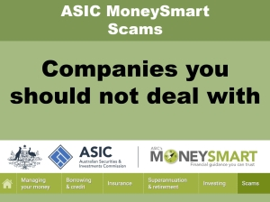

Scams – Identity Fraud
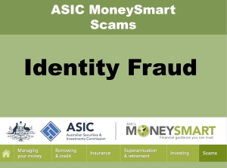

Scams – Investment Scams
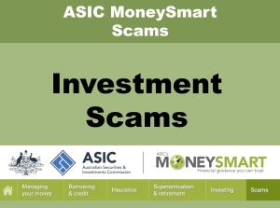

Scams – Superannuation Scams
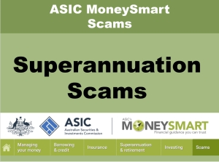

Scams - What to do if I get scammed
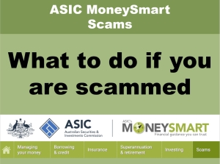

Superannuation & Retirement – ALL
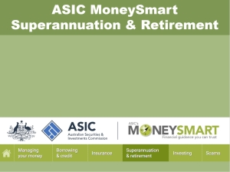

Superannuation & Retirement – How Super Works


Superannuation & Retirement – Is your Super on Target
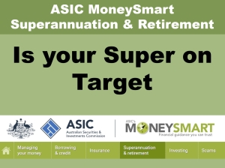

Superannuation & Retirement – Keeping Track & Lost Super
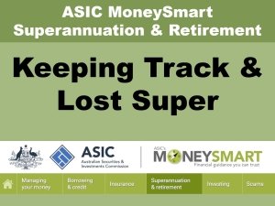

Superannuation & Retirement – Retirement Income
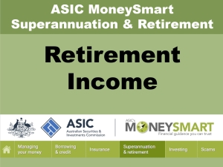

Superannuation & Retirement – SMSF
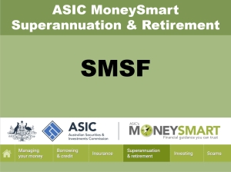

Superannuation & Retirement – Super for Employees
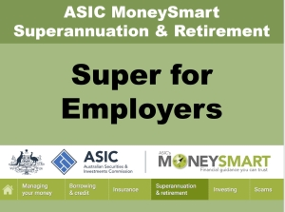

MoneySmart Videos

On the Client Review the presentation is divided into three sections.

These are the links to the videos:

ASICS’s MoneySmart Team (MMTeam)
- Unclaimed Money (0.37) https://www.youtube.com/watch?v=Ao2FswjcCgc
- Debentures explained (3:36) https://www.youtube.com/watch?v=9csx0ImfaT0
- What are Contracts For Differences (CFD’s) (3:23) https://www.youtube.com/watch?v=NYO0u53-w8E
- How to budget – Tips from Heidi and Andrews (1:20) https://www.youtube.com/watch?v=Hka1-d4dXfM
- MoneySmart Video Tour (1:16) https://www.youtube.com/watch?v=x-WJivLfDew
- Savings calculator – Amy saves for a holiday (0.37) https://www.youtube.com/watch?v=x-WJivLfDew
- What is superannuation? – Plan for the party (4:41) https://www.youtube.com/watch?v=b7zQQNkTkzI
- Changing superannuation funds – Tips on super – ASIC (1:11) https://www.youtube.com/watch?v=fDqUqFr-bgc
- Retirement planning – Saving strategies – MoneySmart (1:46) https://www.youtube.com/watch?v=i6MydxPaqOo
- Delia from MoneySmart talks about women and money (2:09) https://www.youtube.com/watch?v=kavHVQULy9Y
- Tax refund – What to do with it – Heidi’s tips – MoneySmart (1:16)
https://www.youtube.com/watch?v=WAMH6zTfwGI

Money Management Kit (MMKit)
- Money management kit – How to use the kit (3.18) https://www.youtube.com/watch?v=vBxSP0ErGLw
- Money management kit – Insurance (2:48) https://www.youtube.com/watch?v=OhU5XA89U5k
- Money management kit -Working in Australia (3:25) https://www.youtube.com/watch?v=E3-KpMC9WYo
- Money management kit – Debt (2:23) https://www.youtube.com/watch?v=i__Jm0iB7fo
- Money management kit – Types of credit (2:37) https://www.youtube.com/watch?v=wKDjK1AfayI
- Money management kit – Credit (3:08) https://www.youtube.com/watch?v=x83056rRdRE
- Money management kit – Banking (3:38) https://www.youtube.com/watch?v=KrvO_WTk00E
- Money management kit – Contracts (2:48) https://www.youtube.com/watch?v=XbiqB7_ZfIA
- Money management kit – Paying Bills (2:40) https://www.youtube.com/watch?v=aPNKGEUs6GM
- Money management kit – Saving Money (2:46) https://www.youtube.com/watch?v=AQ7ZsxLNlQw
- Money management kit – Household budget (2:07) https://www.youtube.com/watch?v=2lAYIpAIrr4

Indigenous Videos (Indigenous)
- Top money tips from financial capability workers (2:01) https://www.youtube.com/watch?v=FLnuVMKrAmg
- Financial capability workers share budgeting and saving (2:01) https://www.youtube.com/watch?v=R1fussuXniE
- Buying a car – Take a minute with your money (2:48) https://www.youtube.com/watch?v=g7tVnrHZ5HM
- Buying a car – MoneySmart (0:56) https://www.youtube.com/watch?v=gZ4dg6SGUxY
- Book Up – Take a minute with your money (1:45) https://www.youtube.com/watch?v=jGZluOmTy7s
- Renting things for your home – Take a minute with your money (2:39) https://www.youtube.com/watch?v=3Ug22spgKYw
- Funeral plans – MoneySmart (0:46) https://www.youtube.com/watch?v=ukdzjwm1x30
- Superannuation - MoneySmart (0:51) https://www.youtube.com/watch?v=sa5VvYxdu1Y
- Avoiding phone bill shock – MoneySmart (0:56) https://www.youtube.com/watch?v=apZBrRlAzfI
- Super Web (0:51) https://www.youtube.com/watch?v=mDJb5zEAkh0
- ASIC’s Indigenous Help Line 1300 365 957 (1:07) https://www.youtube.com/watch?v=4GObPn9V7Ro

Indigenous - Avoiding Phone Bill Shock
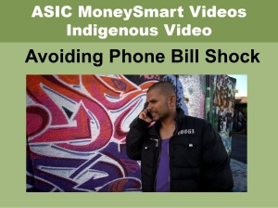

Indigenous – Book Up Tax a Minute
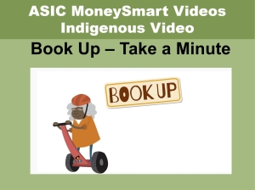

Indigenous – Budget & Saving
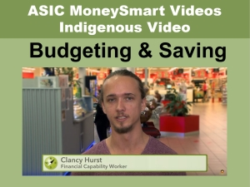

Indigenous – Buying a Car Take a Minute

Indigenous – Buying a Car
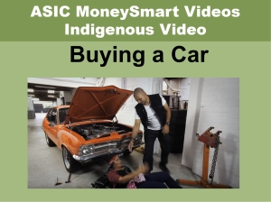

Indigenous – Funeral Plans


Indigenous – Help Line
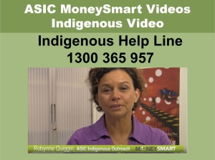

Indigenous – Renting things for your Home
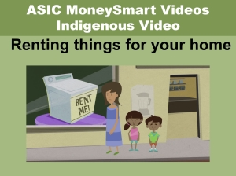

Indigenous – Super Web


Indigenous – Superannuation


Indigenous – Top Money Tips
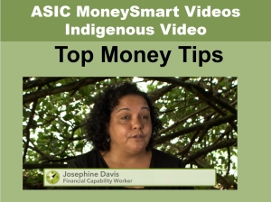

MMKit – Banking
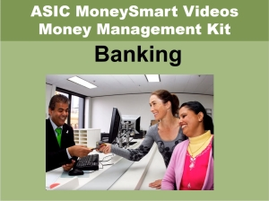

MMKit – Contracts


MMKit – Credit
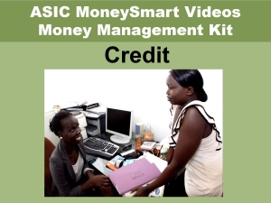

MMKit – Debt
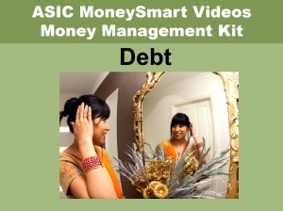

MMKit – Household Budget
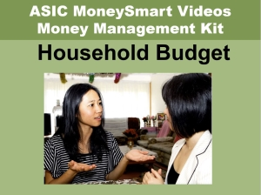

MMKit – How to Use
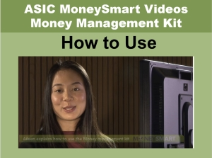

MMKit – Insurance
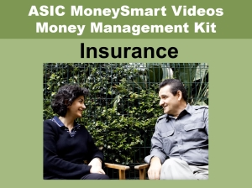

MMKit Paying Bills
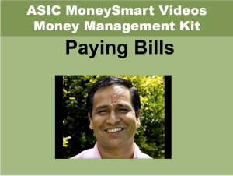

MMKit – Saving Money
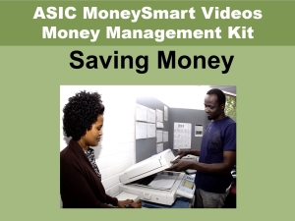

MMKit – Types of Credit
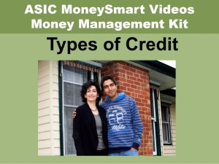

MMKit – Working in Australia
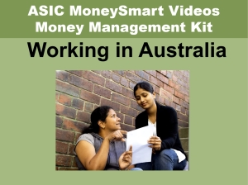

MSTeam – Changing Super Funds
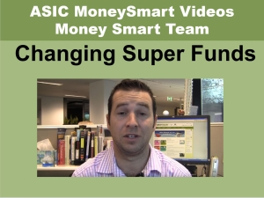

MSTeam – Debentures Explained
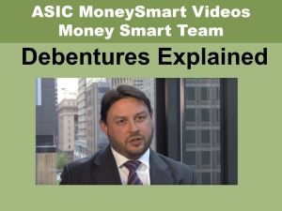

MSTeam – Delia talks about Women & Money


MSTeam – How to Budget
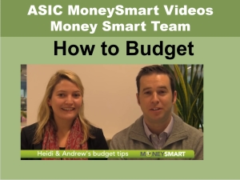

MSTeam – MoneySmart Video Tour
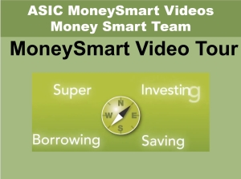

MSTeam – Retirement Planning


MSTeam – Savings Calculator
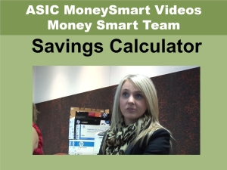

MSTeam – Tax Refund
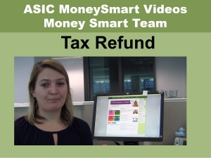

MSTeam – Unclaimed Money


MSTeam – What are Contracts for Difference


MSTeam – Superannuation
