

Template Disclosure Statement

Note: The Disclosure Statement should include the Default Rates you have chosen for your company. To assist in choosing rates this is the Average Rates used over following time periods. As you client can upgrade to a 50-year plan, the 20-year average may be a better choice.

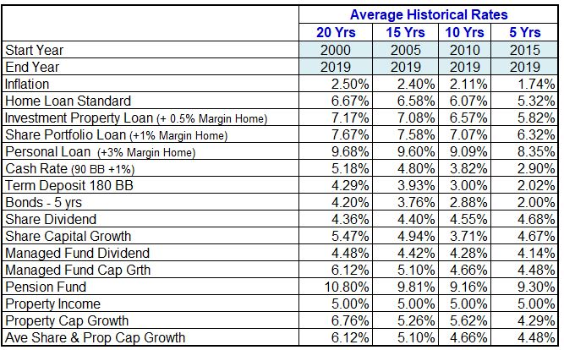

Glenis Phillips SF Fin
Designer of Financial Mappers
Director Plencore Wealth Ltd

Version 04.11.2021
glenis.phillips@financialmappers.com.au
0411 086 532
1300 162 945

Disclosure Statement Template

This software is not intended to offer, or be a substitute for, financial advice. Its purpose is to provide a dynamic mathematical model that shows the cause and effect of various financial transactions which are based on the information provided by you and assumptions about future values.
Default assumptions used for returns on investments are based on the approximate average returns in Australia for the twenty (20) years from the year 2000. In the case of the capital growth for Shares and Real Estate, the software has used the average Capital Growth for both asset classes. The aim is to not give an advantage of one class over the other, because over the very long term, the rates are likely to be fairly similar. In relation to Interest Rates on Loans, the average Variable Standard Home Loan rate has been used for both home and investment property loans. A margin of 1% has been added to Margin Loans for Shares, and a margin of 3% added to Personal Loans. Gross Rent is increased at the rate of Inflation. Actual Rents may not rise in value at the same rate as Inflation.
Please ensure the information that you provide is complete and accurate, otherwise, the projections may not be accurate. Before acting on the information consider the appropriateness of it having regard to your objectives, financial situation, and needs.
All assumptions made and forecasts produced using this software are based on past performance. Past performance is not a reliable indicator of future performance.
You should not rely solely on this software for the purpose of making a decision in relation to any financial product and you should consider obtaining advice from a financial services licensee before making any financial decision.

